Title : The impact of drug trafficking on deforestation.

By Robin DAMEZ

To Alicja BAILLY

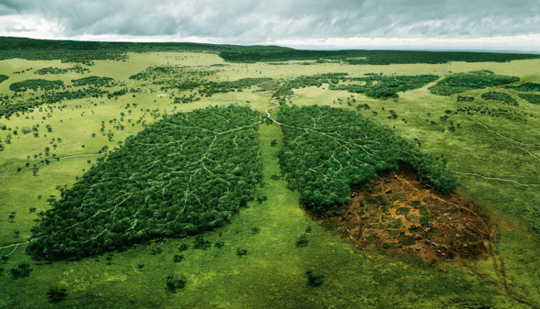

**Contents:**

# Introduction

# Increasing of drug trafficking

# Increasing of deforestation

# Tie between drug trafficking and deforestation

# Conclusion

# Bibliography

# Introduction

The aim of this report is to realize the impact of drug’s traffic on the environment in the South and the Central America. In fact the focus is currently done on the social effect of the drug’s traffic, but it has also an environmental effect.

How the drug’s traffic impact the environment with the deforestation in South and Central America?

Firstly, the increasing of drug traffics, secondly, the increasing of the deforestation and to conclude the tie between these two parts.

# Increasing of drug trafficking

Firstly, the drug trafficking is the illegal trade of drug but it also involves the cultivation, the manufacture, the distribution and sale of the products. These products are subject to drug prohibition laws. In South and Central America, the main drug of the trade is cocaine. The main producer of cocaine is Colombia but its production is falling since 2002.

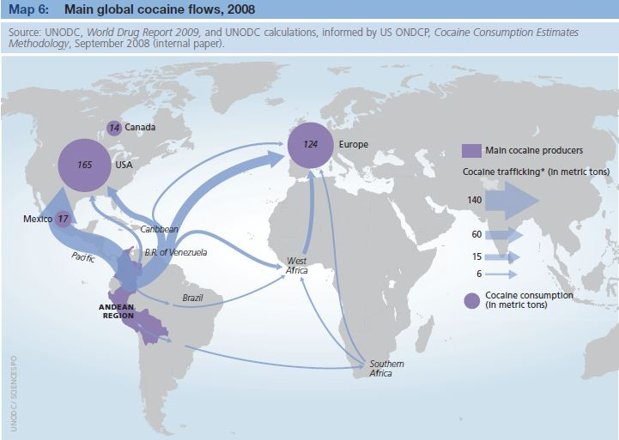

This map shows how drug trafficking is disposed on the world. In fact Europe and USA are the two main consummators of cocaine. As it shows, the principal area of drug’s cultivation is in South America, and the flows which are going to USA are passing by Central America. Indeed “*approximately 65 percent of the cocaine smuggled into the United States crosses the Southwest border*”[1]. That is why this area is also touch by the drug trafficking.

To conclude this part, only the rich countries consume a lot of cocaine, because this drug is very expensive. Also the high price of this drug permits to launder money.

# Increasing of deforestation

First of all deforestation “means the removal of trees and forests, usually through cutting or burning”[2], it is a short but smart definition.

The deforestation has always existed. First in the old times, humans cut trees to make way, or to expand cities. But in modern age the deforestation really increases since the industrial revolution, with the “intensive” agriculture. In fact the “intensive” agriculture requires vast lands to have large plantation. That is why they clean up the forest they cut down each and every trees to have more and more benefices.

And this has an impact especially in South America on the Amazon rain forest.

Nevertheless since 2000, the deforestation by agriculture has fell because the Brazilian population have waking up, and many people feel themselves concerned by the problem of the deforestation.

However “intensive” agriculture is not the only cause of deforestation, now there is a rise of the deforestation owed the drug trafficking.

# Tie between drug trafficking and deforestation

Bibliography :

<http://www.bbc.com/news/science-environment-25960481>

<http://researchnews.osu.edu/archive/narcodeforest.htm>

<https://www.unodc.org/>

1. By Drug Trafficking in the United States – Almanac of Policy Issues
2. Gapyear.com – Deforestation in South America by Leilani Jordan